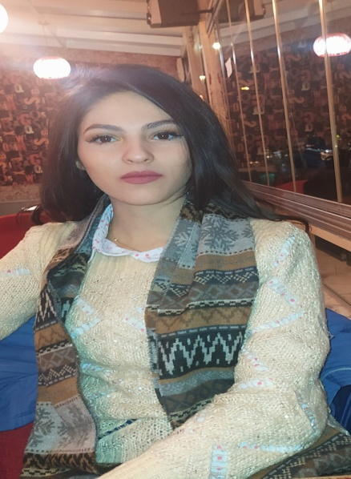

**Contact**

**Nationality:** Syrian Arab

**Marital Status:** Single

**Address:**

Lattakia ,

**Phone:**

+963938265317

**Email:**

Aya781998@gmail.com

**Languages**

English: Full Competence

Arabic: Native

**Summary**

Professional speaker of English and a certified English conversation and coach.

**Skill Highlights**

|  |  |
| --- | --- |
| * Flexible personality * Perfect team worker * Creative thinker * Motivational * Service-focused |  |

**Experience**

* Private tutor at ETC – Syrian Coast (Educational Trust Center).
* Translating from English to Arabic, Arabic to English (Pamphlets / Articles).

**Education**

* English literature graduate 2020

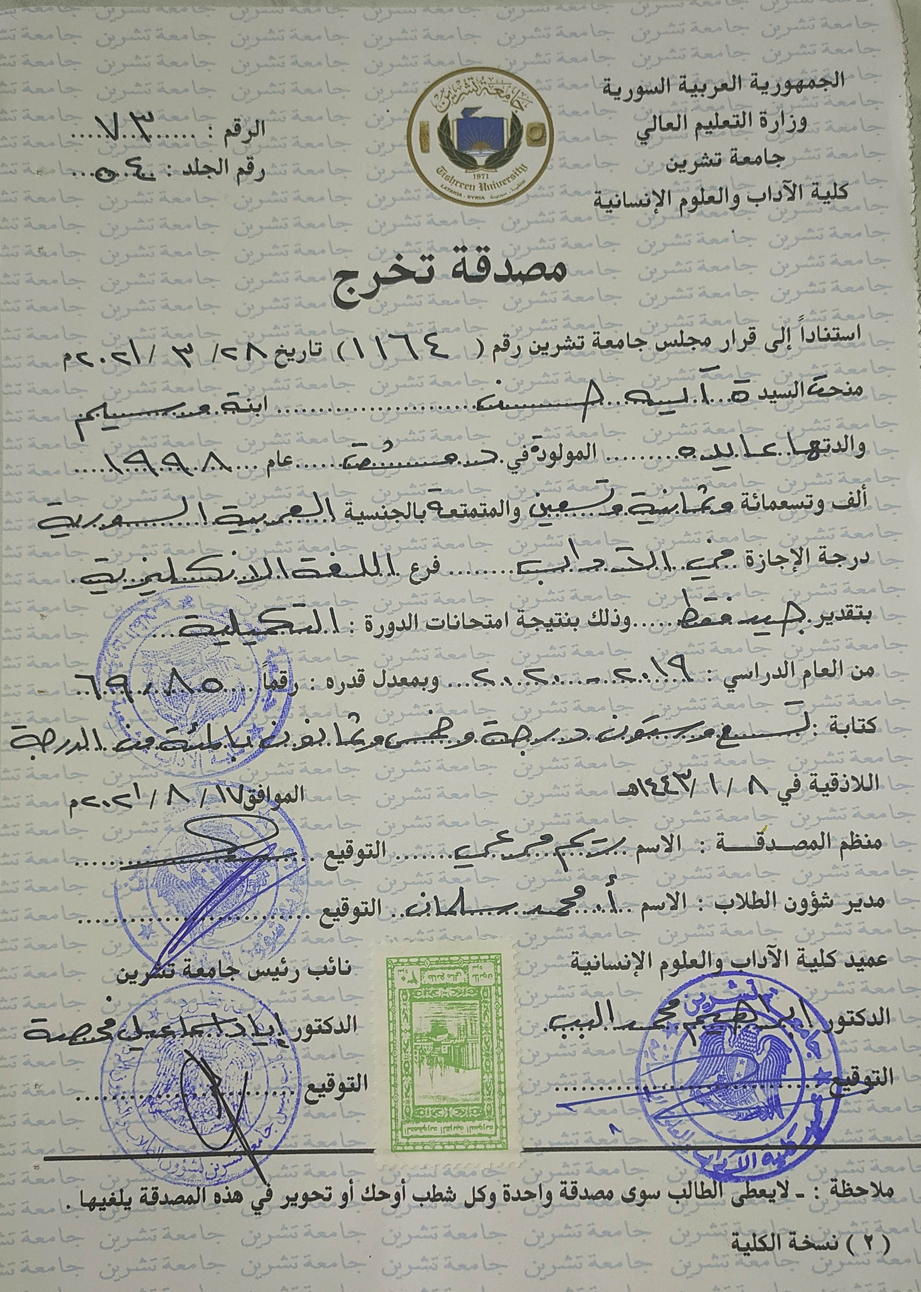

* Educational Qualification Diploma 2021/2022

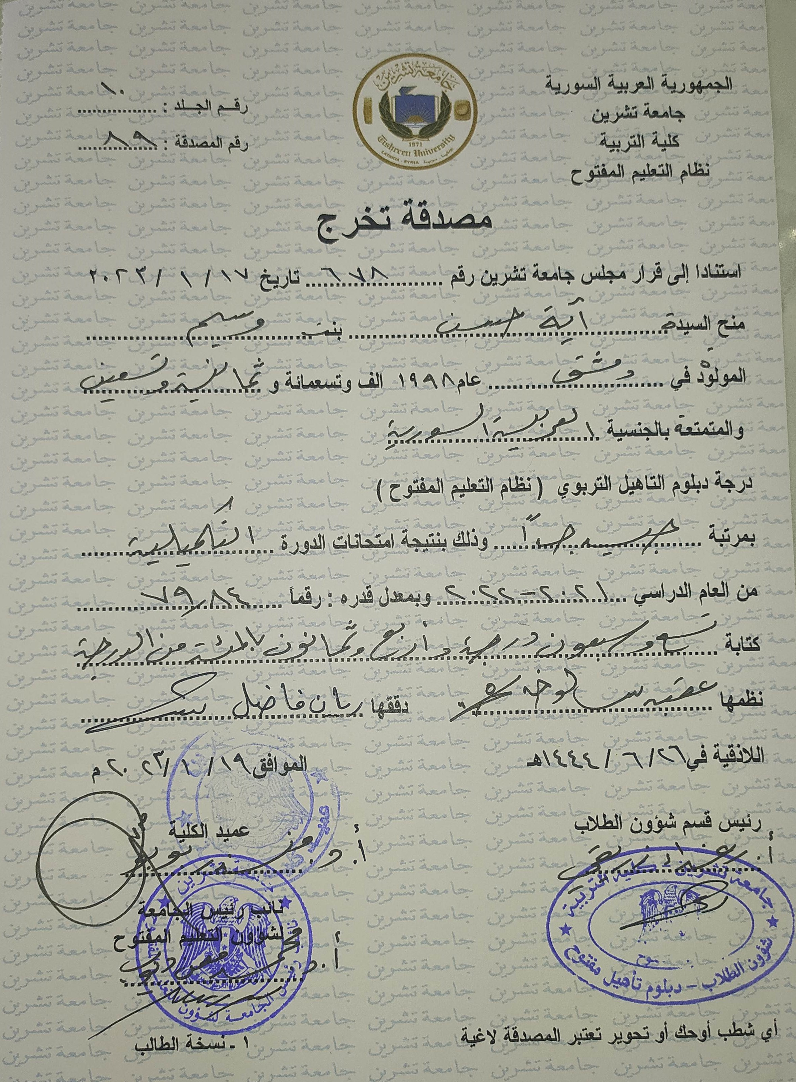

**Certifications**

* Certificate by Rai Language Center
* Certificate by TTD Academy UK

**Aya Hasan**

**7 August 1998**